Jing Du, Minji Kim, Beiqing Song

ISYS3340: Data Analytics in Practice, Prof. Sebastian Steffen

Dec. 12, 2022

**A Deep Dive into the Video Game Industry**

### Executive Summary

The report describes trends in the gaming industry from 1994 to 2022, collecting the dataset from game review and sales tracking websites: Metacritics and VGChartz respectively. Over 13,800 records from the sites were used in the analysis. For our first argument, we used line graph visualization tools and regression (t-test) to find that the video game industry has expanded in all aspects despite experiencing fluctuations due to some major events. The second argument convinced us that the scores users gave have been lower over the years. Beyond this, we took a further step to discover which factor causes the changes in userscores and metascores and found that the M-rating games tend to have lower userscores while E or PG ratings show lower metascores. Other meaningful findings are also presented to analyze the underlying factors behind the more divergent opinions of critics and users. Critics were becoming relatively more conservative and rated the games in the context of the larger environment, whereas users were less tolerant because more options were available. We also found that critics were biased towards classical games with multiple series and developers with long histories. Overall, as the market expands and as the opinions of the two parties become more divergent, it is vital for developers to consider which advice they should take to better meet the interests of the target customers. In conclusion, we recommended that future developers utilize more reliable review websites for analysis and pay more attention to the reviews of gamers who can truly speak about the customer experience to differentiate their products and create a unique experience for the users.

### Introduction & Motivation

The video game industry is one of the fastest-growing industries in the world (“Video games,” 2022). Having a market value of $7.98 billion in 2001, the video game industry expanded rapidly and reached a market value of $178.37 billion in 2021 (Statista Search Department, 2021). At the same time, contributing to the development of technology over the past decades, the market has attracted a much larger and more diverse population of video game players in recent years. The number of gamers increased from 2.03 billion in 2015 to 3.09 billion in 2022. 66% of the U.S. population plays video games regularly and video games have become a valued part of many people’s lives (Urbanemujoe, 2022).

However, the overall positive trend does not represent the environments and stories underneath, including changes in gamers’ preferences, popularity trends, media critics, game qualities, potential bias, etc. A great example is the backlashes from gamers to one of the most popular games in 2020 – *The Last of Us Part II.* This game receives an average rating of 93 out of 100 from 121 critics, which was the second-highest Metacritic score in 2020. However, it receives a poor 5.7 out of 10 from 160,000 players. The large gap between critics’ and gamers’ reviews inevitably led us to question whether video game developers nowadays pay too much attention to meet the expectations of critics yet ignore the interests of common gamers. Driven by questions like this, our team was eager to learn more about the trends and changes underneath the fast expansion of the video game industry and present a story based on our findings.

### Discussion & Method

To get our data, we scraped two websites: Metacritic and VGChartz. In the scraping process, we were especially concerned about asking permission from the webserver to scrape the pages. Hence, we incorporated the bow command from the polite package within the function. We mainly used the rvest package to scrape useful information.

From the main pages of Metacritic, we acquired information about the names, platforms, release dates, metascores, userscores, and individual URL links for each game. We then ran a for loop within the function to click into each URL and scrape more information about the developers, genres, numbers of critic reviews, and numbers of user ratings for each game. Again, we used the polite::nod command here to ask for permission to scrape these links of link. If permission is denied, if any URL link turns out to be a 404 error, or if any information is not available, the function will return “NA” in the corresponding cells and continue to the next iteration. The function ultimately scrapes all 199 pages and outputs a data frame. For VGChartz, the only information we acquired from this website is the sales of each game on each platform.

We then moved on to clean the data and join the two data tables. We manually filtered out the sales of all platforms combined and all series combined because there is not any match for “All” and “Series” in Metacritic. Moreover, we cleaned the names of the platforms to match those in Metacritic. For example, the console name “N64” in VGChartz was changed to match “Nintendo 64” in Metacritic. We also excluded the consoles that do not appear in Metacritic, and we used str_extract to turn the sales into numeric values. Using lubridate package, we changed the release date variables to date formats. Because each game often has two or more genres associated with them, we extracted the first element in the list as the main genre via stringr package. However, we made a mistake here to forget to include numbers and signs like “-” and space in the regular expression, so many genre names are incomplete. For example, “3D” becomes “D” and “Sci-Fi” becomes “Fi.” Even though most names do not have a significant impact on our analysis, there is one that limits our exploration. Both “First-Person” and “Third-Person” games become only “Person,” so these two genres are actually combined when they should not. However, it would be interesting to explore the differences between First-Person and Second-Person genres, as they provide very different customer experiences.

In order to join the two different datasets,we attempted to clean the game titles, which contain multiple variations on characters, such as é in any Pokémon game. After handling those exceptions and making the titles as similar as possible, we used fuzzyjoin with max_dist 0 on game titles to combine two tables together. 0 max_dist means the game titles should be exactly the same, and some games may be lost in the process. There are 13,805 records in the final dataset after the process. To make metascores and userscores more comparable, we multiplied userscores by 10 to put them on the same scale out of 100.

For the first argument, we argued that the video game industry overall has expanded massively in terms of the total number of games released. If the video game industry expanded, there would be more participants entering the industry, leading to an increase in the number of games released. We focused on this measure rather than the total video game sales that occurred each year because a large portion of video game developers are not public companies and consequently do not publish their sales figures.

To ensure the objectivity of our findings, we filtered out the data from the pandemic years. We then did a regression and discovered that the “year” variable is significantly and positively correlated with the total number of games released each year (p<0.05). However, we noticed that the regression does not represent the variations in the data well. Three major trends that happened throughout the 30-year period are worth mentioning. As shown in the graph (Appendix 1), the number of games released significantly increased, decreased, and then increased. The decrease from 2002 to 2015 was caused by market saturation. Large developers started to have economies of scale, and many smaller developers were either dismissed or acquired by larger developers. Our regression supported that the number of game developers decreased during that period (Appendix 3). The increase from 2015 to pre-pandemic was related to the blow-up of indie games. From 2010 to 2012, successful indie games such as *Terraria, Minecraft, and the Binding of Isaac* showed that games developed by a small team without extensive advertising could become extremely popular.

Next, we focused on the number of games released within different genres and platforms each year. We noticed that the number of sports games released decreased over the years (Appendix 4). This is because the sports game market is highly competitive, and developers with famous IPs gradually dominate the market. NBA 2K is a great example given that it is the only AAA basketball franchise in the market and its success was driven by NBA’s authorization to put famous real-world teams and players in the franchise. We also found that the PC market has been very consistent over the years (Appendix 5) because PC gaming has a higher cost than console gaming. A custom-built PC can easily cost over 1 grand, and a high-performance PC can easily cost over 2 grand. Because of this barrier of entry, the customer base of the PC gaming market has remained stable, leading to a consistency in the number of games released on PC every year.

Our second argument is that games have lower average ratings over the years. We first created a line plot of users’ scores (userscore) and critics’ scores (metascore) over time (Appendix 6). While there are differences between userscores and metascores, both metascores and userscores have significantly dropped in the interval between 1999 and 2000. Given that the launching year of the Metacritics website is 2001, it may cause a bias in scores. Many old games prior to 2001 do not have enough reviews from critics and users, and those that do have metascores and userscores consist of reviews from fans who have a strong emotional attachment to the games and tend to rate these games highly (Appendix 7). We also thought that as the market expanded and attracted new entries, more low-quality, low-cost games were flowing into the market, so both metascores and userscores were getting lower on average.

Though the null hypothesis was already rejected with the line plot with inconsistent average scores each year, our team decided to take additional steps to discover what causes the fluctuations of scores after the year 2000. Though it is highly challenging to find all the main factors behind the opposite trends in metascores and userscores due to many ambiguous feedbacks, one of the factors is the rating. First, we split the data based on genres and created another column diff, which represents the differences between userscores and metascores. Higher diff indicates relatively higher userscores compared to metascores, and vice versa. By comparing games with the lowest and highest diff from the year, we found an interesting fact: the M and T rating games tend to have lower userscores, while E and PG ratings get lower metascores (Appendix 8,9). The major complaints from M and T ratings are graphics, soundtracks, and network issues; most games with these complaints have extremely low userscores because many users write their feedback based on their negative experiences and ignore all other advantages. PG and E-rating games, on the other hand, do not have complaints about the issues, seemingly lowering the expectation of these elements. However, critics apply a strict standard, giving lower scores if the new game has no exceptional features compared to the existing ones. For example, Monopoly Party! has lots of positive user reviews, saying the game does what a monopoly game should do. However, critics were disappointed and simply labeled it as a boring game.

Moreover, to investigate how the metascores and userscores for different genres changed over time, we grouped by genres and years to identify the three genres that have the highest average metascores for games released before 1998. These three genres are Miscellaneous, Driving, and Strategy. We plotted the average metascores, userscores, and the number of games released across the years of each genre using ggplot line charts (Appendix 10, 11, 12). Overall, the metascores and userscores showed a downward trend, and userscores decreased more dramatically than metascores in recent years. Both the graphs and a separate regression supported that the average Driving metascore decreases as the number of Driving games released in that year increases (Appendix 13). This regression result is also replicated for both Miscellaneous (p = 4.44e-05) and Strategy (p=8.9e-0.5). However, this relationship is not found between average userscores and the number of games released, suggesting that userscores are more immune to the influence of the number of same-genre games in the industry.

We were also interested in the difference between metascores and userscores over years in terms of variance, so we plotted their standard deviations against years. Both metascores and userscores are more spread out from 1994 to 2000, mainly due to the dramatic increase in the number of games released. After 2000, the standard deviation of metascores is relatively constant, but after 2010, the standard deviation of metascores dramatically decreased, suggesting that the scores critics gave are closer to the mean. The standard deviation of userscores is consistently increasing all the way from 1995 to 2022 (Appendix 14). Overall, it seems like critics were more conservative and concerned about the game in the context of the larger environment, like the number of games released. However, users were less tolerant because more games are available for them to choose from.

We also found that critics were biased toward series games. We first identified the three developers that are rated the highest on average by metascores before 2000, and they are Polyphony Digital, KCEJ, and Visual Concepts. KCEJ stopped producing after 2005, so we excluded it from the analysis. For developers that have series games, like Polyphony Digital’s Gran Turismo and Visual Concepts’ NBA 2K, their original versions are the most successful, and the successive series show a downward trend, especially in userscores. As shown in the line charts, throughout the years, metascores are consistently higher than userscores, and the gap between the two scores is getting wider (Appendix 15, 16). Polyphony Digital’s Gran Turismo 7 in 2022 has the biggest discrepancy between metascore (87) and userscore (21). Similarly, Visual Concepts’ newest NBA 2K21 on PS4 has historically low userscore (9) compared to metascore (68). When running a regression on the gap between the two scores on years, both Polyphony Digital (p=0.0625) and Visual Concepts (p=0.00032) return a positive correlation between the gap and years, confirming that the gap is getting wider in recent years (Appendix 17, 18).

### Conclusions & Findings

With analysis regarding our first argument, we concluded that the video game industry has expanded overall throughout the last thirty years, but there were inconsistencies in different game genres and platforms due to variations in competition, barriers to entry, and other factors. The second argument has two intriguing findings. First, games before the year 2000 are inclined to have biases in scoring from fans, and second, there is a relationship between scores and ratings. While M-rating games are prone to have lower userscores due to users who evaluate games based on a few negative experiences, E-rating games have lower metascores because some critics expect different features from games that already existed in the market.

Moreover, combining the different regression results between metascores and userscores against the number of games released and their different standard deviations, we thought that critics are becoming relatively more conservative in terms of the scores they give and more concerned about the game in the context of the larger environment, like the number of games released. On the other hand, users are becoming pickier and less tolerant because more games are available for them to choose from, so users give scores that represent their true interests based on their evaluation of the experience with the individual games.

Moreover, while critics seem to have a classical bias towards games with multiple series and developers with longer histories, users do not seem to have this bias. In fact, users and fans who played the early series before are more judgmental about the newly released series because they have expectations that the newly released ones would improve in terms of quality, creativity, and uniqueness. However, reading some comments of the users, they were often disappointed by the new series, saying that the new ones are no different from the previous series and their complaints about the previous series are still unresolved.

### Recommendations & Next Steps

Overall, as the market expands and as the opinions of critics and users become more different and diverged, it is essential for the developers to consider which advice and comments they should take from each party and how they can use the reviews to better meet the interests and demand of the target customers.

One crucial limitation we noticed with the Metacritic website is that Metacritic does not require users to actually play the games for a certain amount of time to write a comment. Anyone logging into Metacritic can write a review easily, which affects the userscores of the games. Therefore, there would be some users’ reviews that are overly emotional and irrational due to external factors other than the quality and experience of the games.

While the reviews of both critics and users can sometimes be biased and meaningless, it is crucial for future developers and new entries in the market to focus on the comments of the actual gamers who physically play the games for a certain amount of time and can truly speak about the customer experience so that they can differentiate their products to create a unique and joyful experience for the users. One way to accomplish this can be that developers implement questionnaires within the games or through gamers’ registered emails to collect useful advice from the actual players. Also, there are platforms like Steam that require anyone who wants to leave a review to own and play the game for at least 5 minutes. Reviews and comments on these platforms might be more reliable than Metacritic for developers to consider.

Moreover, the wider gap between metascores and userscores also creates difficulties for customers who try to find a game that meets their interests, and reading through each individual comment of each game option can be time-wasting as well. Therefore, one of our next steps can be creating an algorithm to extract the most frequently appeared words or phrases in the critics’ reviews and users’ comments and present the lists to the customers so that they can get a quick and genuine sense of how critics and users in general feel about the gaming experience. Of course, we would recommend this algorithm be done with a more reliable website like Steam or Epic. The latter platform creates a specific solution to prevent review-bombing by randomly selecting players who have played the game for more than two hours to give a rating.

References

*METACRITIC: THE HISTORY*. Metacritic. Retrieved December 12, 2022, from

https://www.metacritic.com/about-metacritic#:~:text=Metacritic's%20three%20founding%20members%E2%80%94all,the%20single%20Metascore%2C%20a%20weighted

*Video games: The industry of the present and the future*. EAE. (2n.d., January 20). Retrieved December 12, 2022, from <https://www.eae.es/en/news/eae-news/video-games-industry-present-and-future>

Statista Search Department (2021, November 23rd) *Video gaming market size worldwide 2020-2025* [Infographic]. Statista. <https://www.statista.com/statistics/292056/video-game-market-value-worldwide/>

Urbanemujoe. (2022, June 10). *2022 essential facts about the video game industry*. Entertainment Software Association. Retrieved December 12, 2022, from <https://www.theesa.com/resource/2022-essential-facts-about-the-video-game-industry/>

### Appendix

Github Link: <https://github.com/Cassiedu66/2022_bc_isys3340_group3.git>

1. Total number of video games released each year over the last 30 years

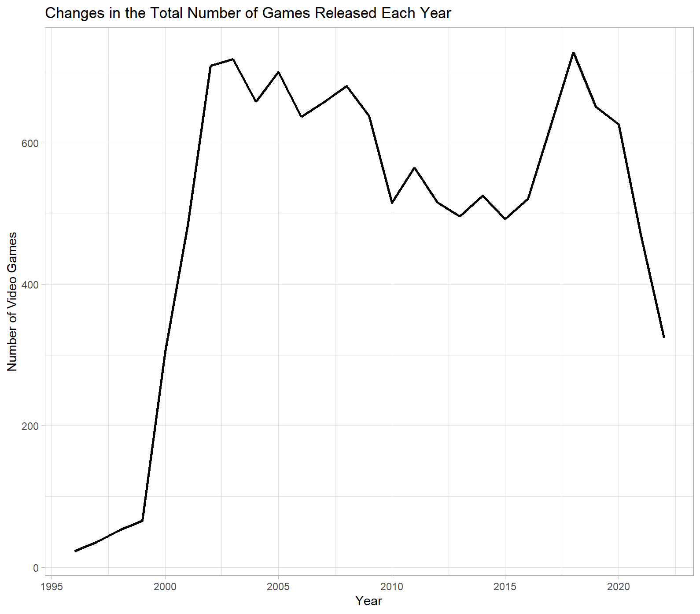

1. Screenshot of the result of the regression about the number of games released each year from 1999 to 2022

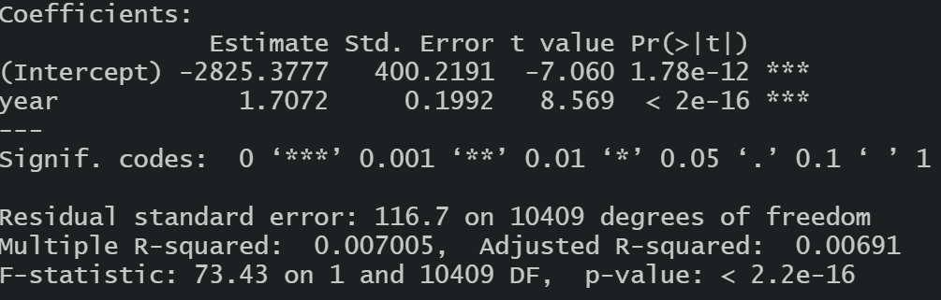

1. Screenshot of the result of the regression about the number of game developers from 2015 to 2019

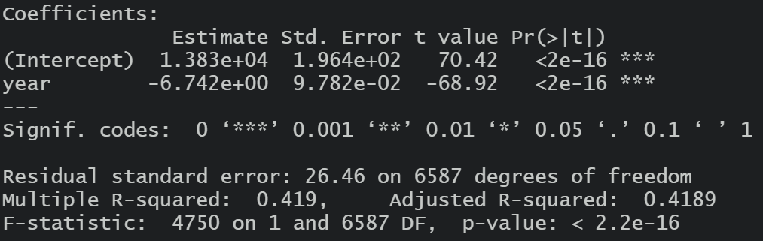

1. Total number of different genres of games released each year over 30 years

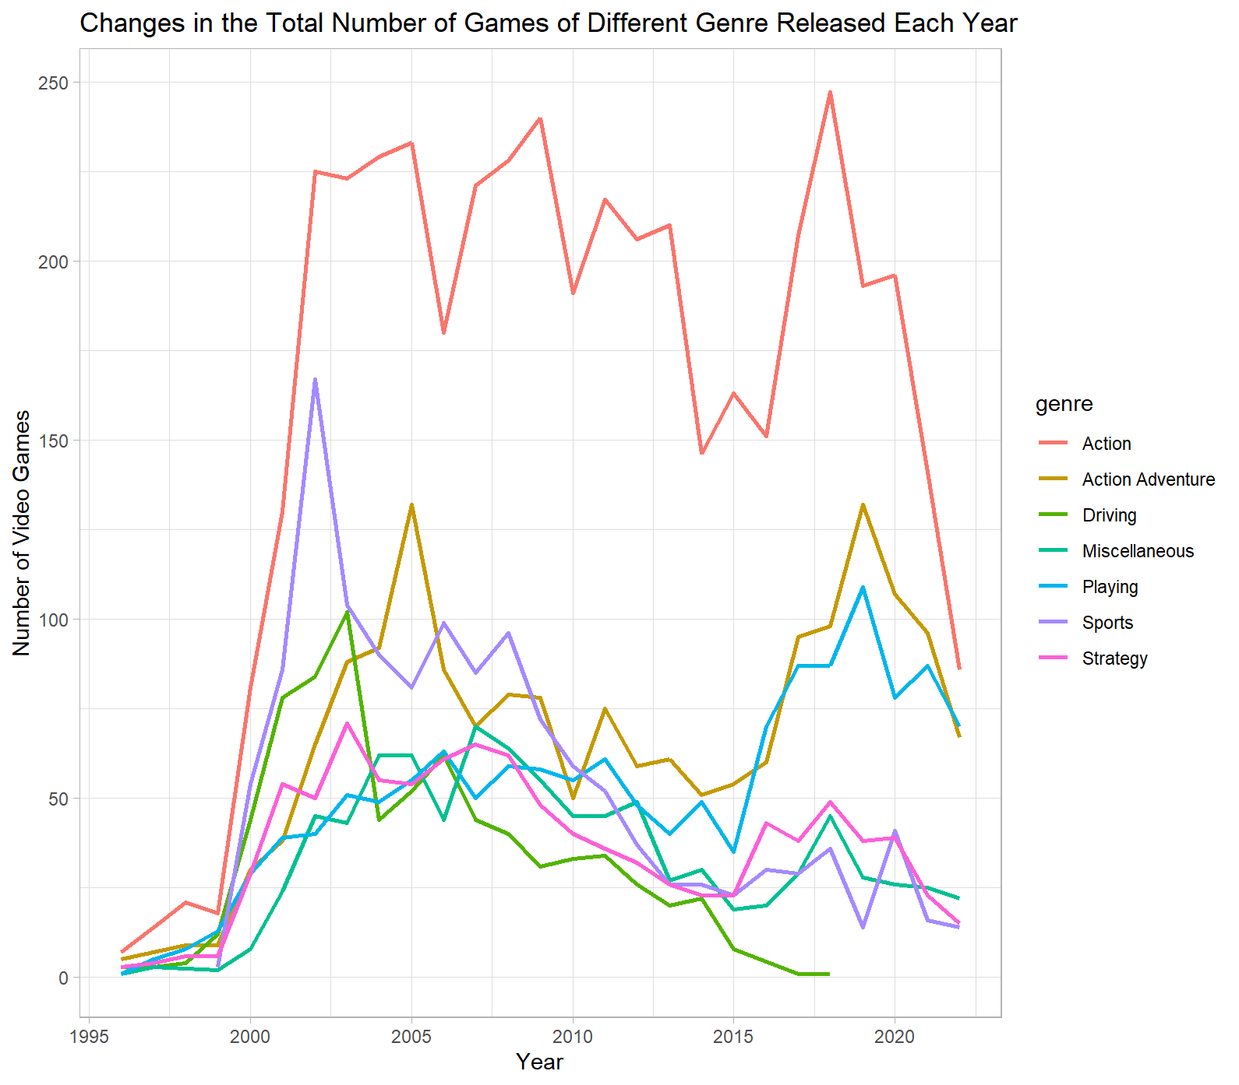

1. Total number of games released on PC every year for 30 years

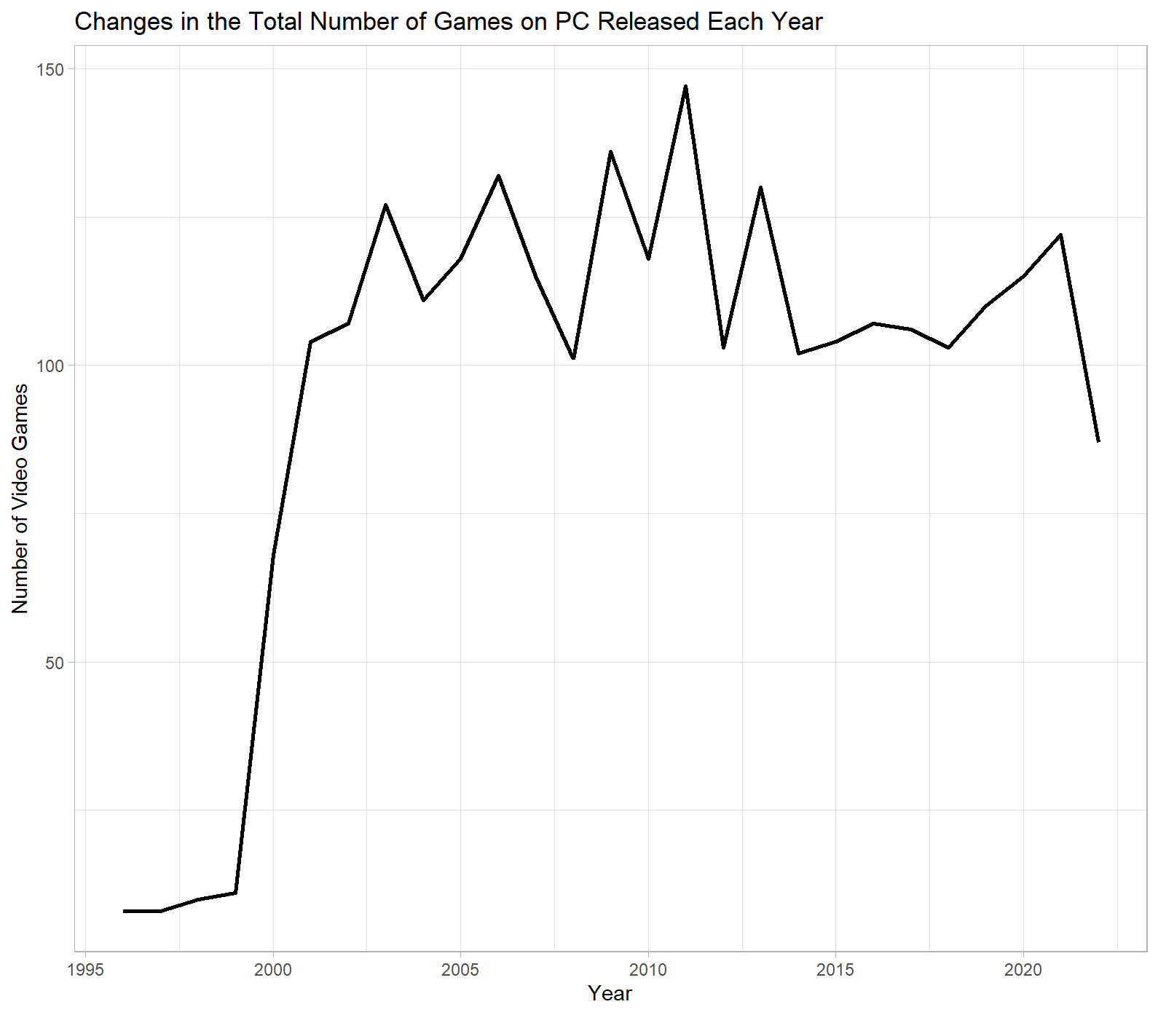

1. Userscore and metascore over time

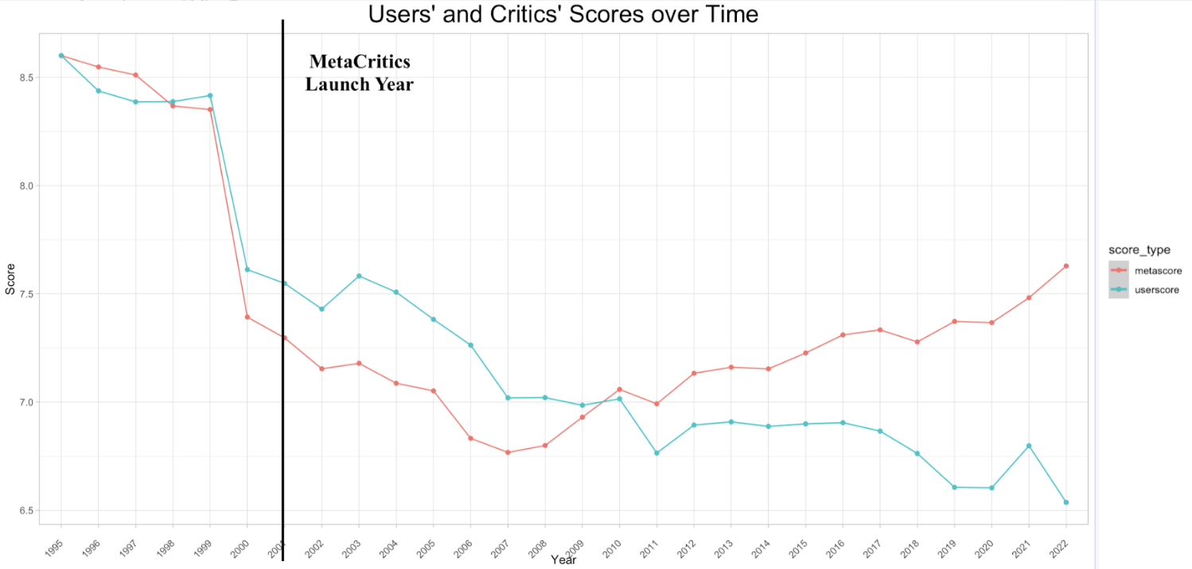

1. The evidence of bias in old games from fans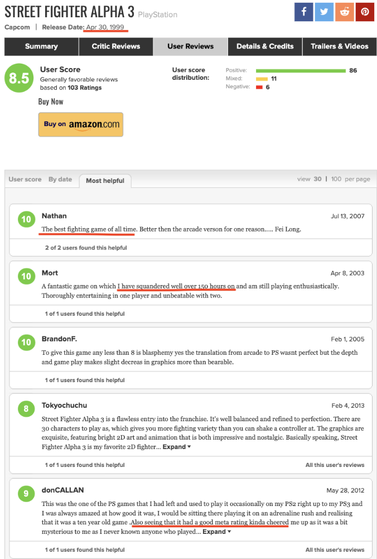
2. The top 10 lowest diff with underlined rows representing M and T ratings

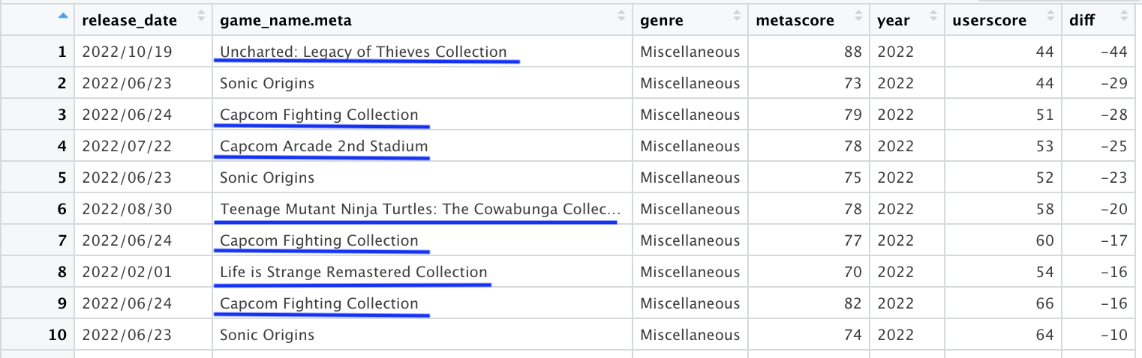

1. The top highest diff with underlined rows representing E or PG ratings

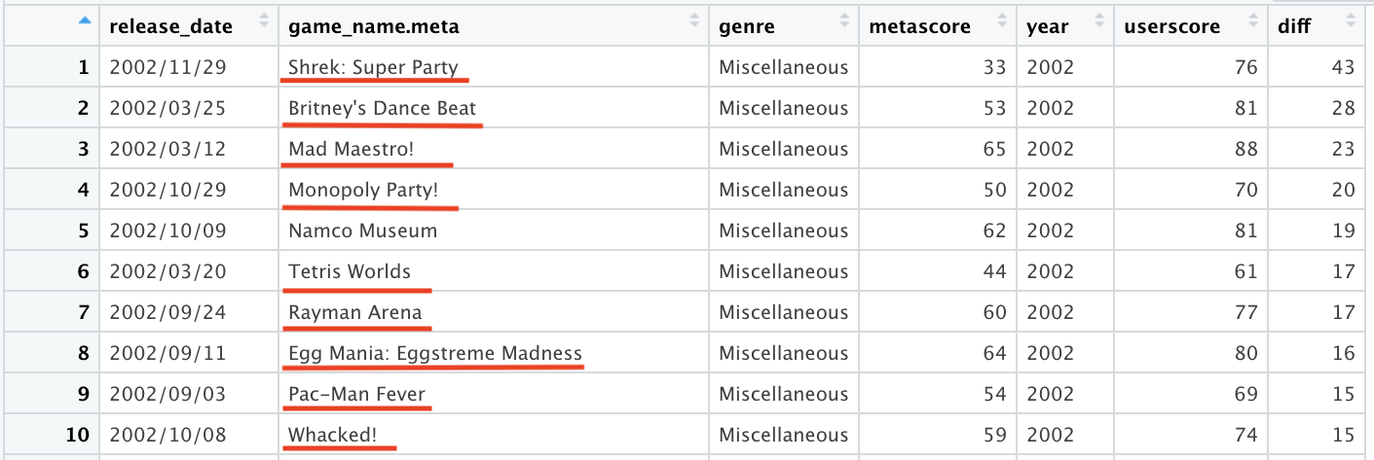

1. Average metascores, userscores, and numbers of games released for Driving genre over the years

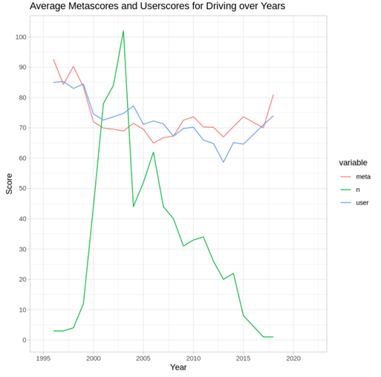

1. Average metascores, userscores, and numbers of games released for Miscellaneous genre over the years

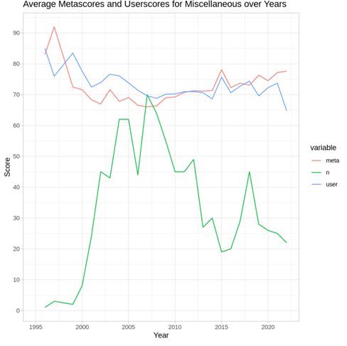

1. Average metascores, userscores, and numbers of games released for Strategy genre over the years

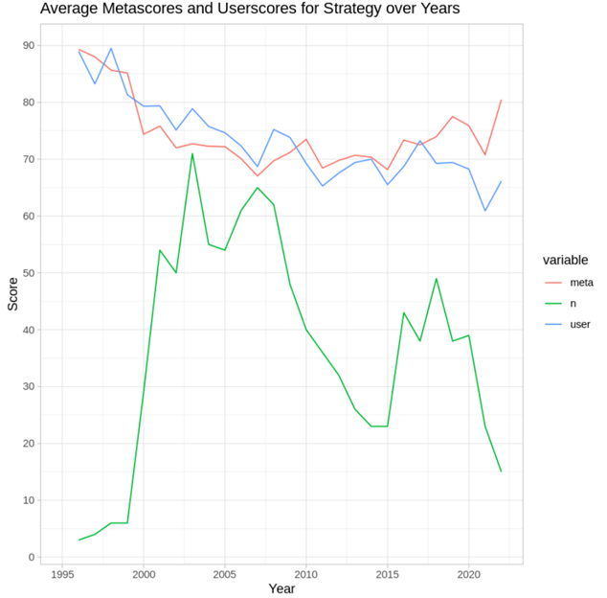

1. Regression on average metascores and numbers of games released for Driving

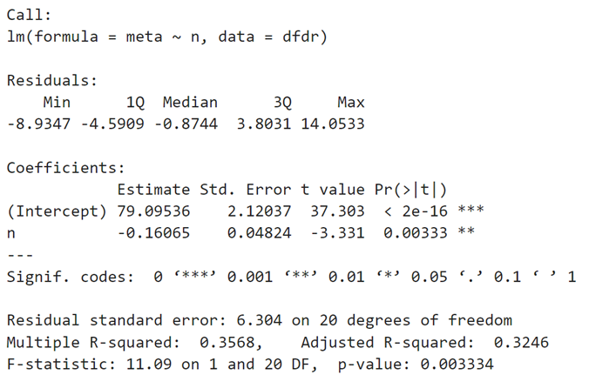

1. Standard deviation of metascores and userscores over the years

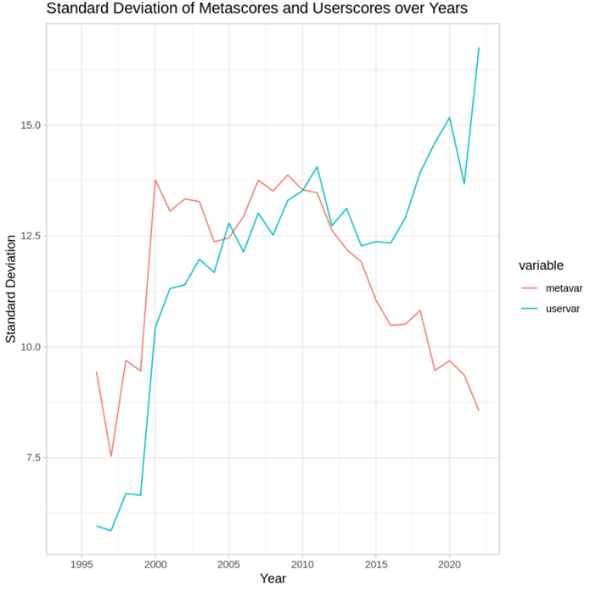

1. Average metascores and userscores for Polyphony Digital over the years

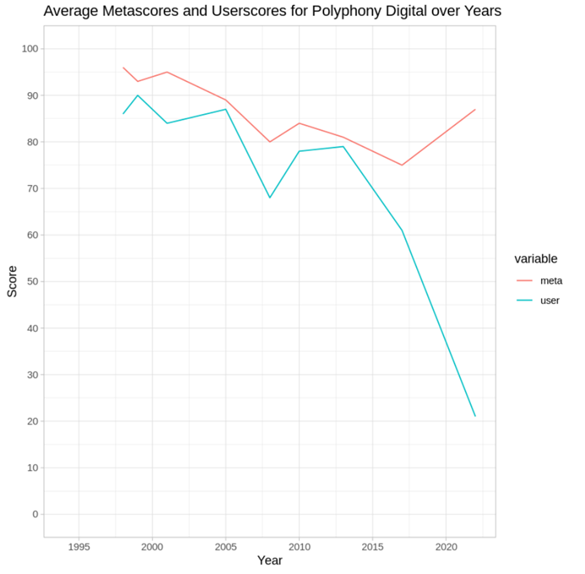

1. Average metascores and userscores for Visual Concepts over the years

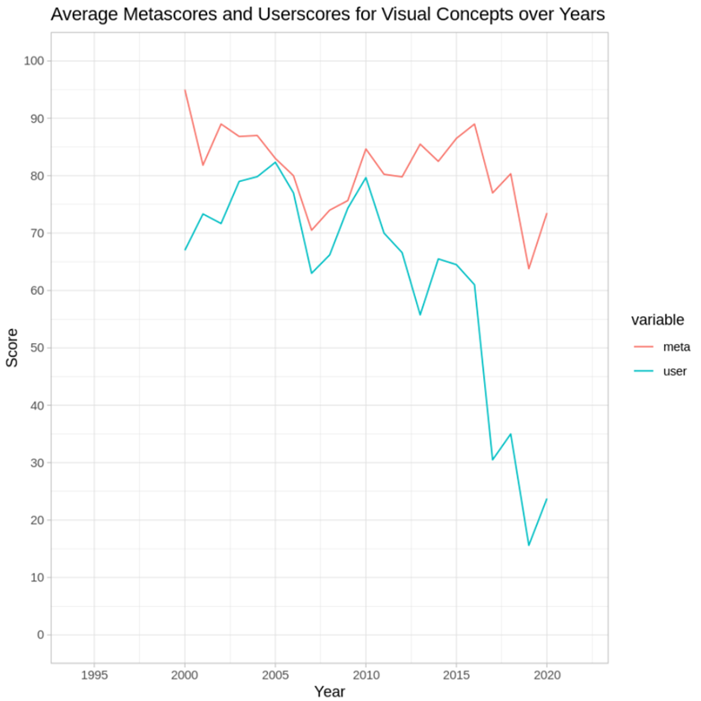

1. Regression on the difference between metascores and userscores over years for Visual Concepts

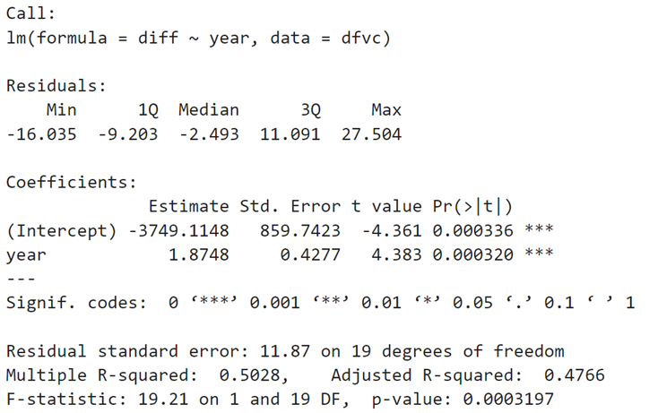

1. Regression on the difference between metascores and userscores over years for Polyphony Digital (marginally significant)

